**The sum symbol:**

In mathematics, we use ∑ (greek letter for sigma) to denote a sum. For example:

Denotes the sum S of all integer numbers i between 1 and a given n, or:

Similarly,

**The product symbol:**

In mathematics, we use (capital letter greek letter for pi) to denote a product. For example:

Denotes the product of all integer numbers i between 1 and a given n, or:

Given a two numbers m and n, we can write the exponentiation (m raised to power n or ) as:

**Ex 15 :**

**(This exercise was given as the first test):**

Given two positive integer numbers m and n, compute:

and output the result to the JS console.

**Ex 16 :**

Write a JS program that will ask the user to enter a value of n (using prompt). Then, output to the console, the following sums:

For the value of you should use the code from exercise 15.

**Ex 17:**

In mathematics, is defined as the constant the ratio between a circle’s circumference and twice its diameter. There is a very interesting method of computing which was discovered by Gottfried Leibniz:

<https://en.wikipedia.org/wiki/Leibniz_formula_for_%CF%80>

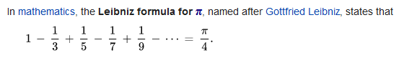

From the above, we can write as:

There is no way of using infinity (∞) inside a computer. However, we can test the above formula for different possible values. We therefore must replace ∞ with a given value, let us denote that with n:

Write a JS program that will ask for a value of n (from the user) and output the value of the computed . Run your program several times and observe the computed value.